UNIVERSITY OF AZAD JAMMU AND KASHMIR


Subject:
Graphic Designing.

Paper:
Lab Mid-term paper.
Submitted by:
Name: Toseeq
Roll no: 2024-CET-30

Submitted to:
Engr. Ahmed Khawaja
Date:
30-April-2026

Mid Term Lab Exam
Q#01:
A new student society named “Creative Tech Society” has been launched in the Department of Software Engineering. The society wants to promote its first event, “Design Sprint 2026”, where students will learn basic poster designing, logo designing, and branding skills. The society needs to design:
- A promotional poster for the event.
Apply the concept of Principles and elements of graphic design and make the poster.
Design:
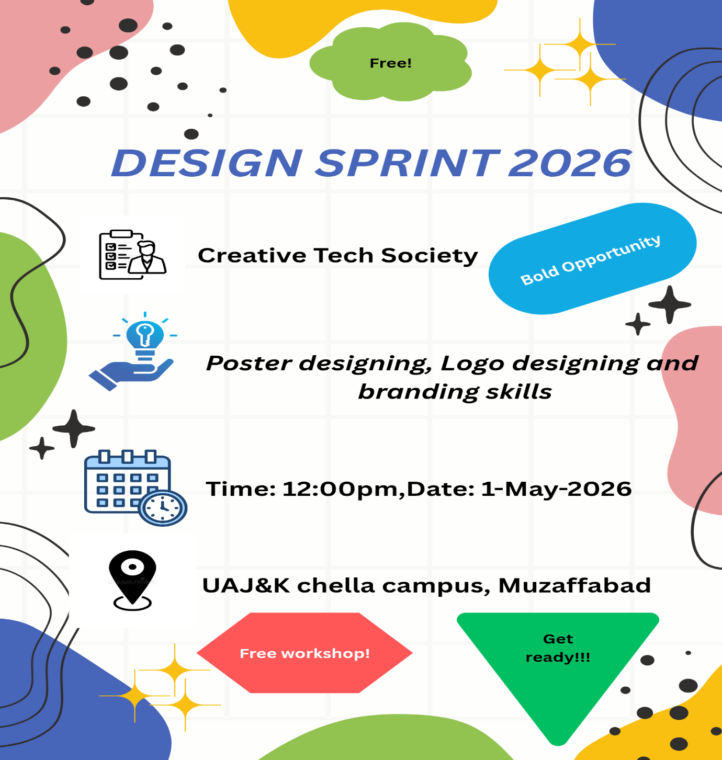
- Poster includes:

- Event Title: Design Sprint 2026
- Organizer: Creative Tech Society
- Date, Time and Venue
- Activities: Poster Design, Logo design, branding.

- Apply design principles:

- Hierarchy
- Big, bold, title at top.
- Medium text for details.
- Small text for extra info.

- Contrast
- Use light text on dark background(or vice versa)
- Highlight important words.

- Alignment
- Keep everything aligned.

- Balance
- Distribute text and images evenly.

- White spaces
- Leave empty space so design doesn’t feel messy.

- Use design elements:
- Color scheme: Blue + Purple.
- Fonts:
Title = Bold.
Body= simple readable font.

- Clarity:
I use icons and shapes to make design clear, understandable and attractive.

Mid Term Lab Exam
Q#02:
Design a simple and meaningful logo for “Creative Tech Society.”
The logo should represent creativity, technology, teamwork, or innovation. It should be suitable for use on posters, certificates, social media pages, and event banners.
Logo design:
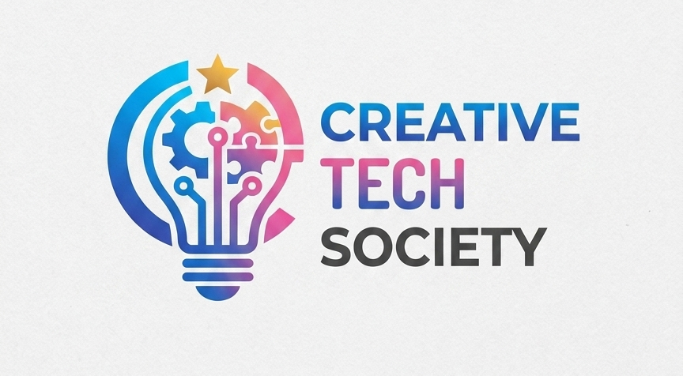

- This logo contains Creativity, Technology, Innovation and Teamwork.
- Simple idea used in the logo, A light bulb + circuit lines.
- It is suitable for use on posters, certificates, social media pages, and event banners.
- It follows design principles such as Simplicity, Scalability, Relevance and memorable.
- I use Blue, Purple and Black colors and clear font.

Mid Term Lab Exam
Q#03:
A start up named “Green Byte Solutions” is launching an awareness campaign titled “Save Energy, Save Future.” The start-up wants a poster to promote the campaign.
Students will design:
A campaign poster
Note: Your campaign design should have a proper structure, clear message, readable text, a suitable green/environmental color scheme, balanced spacing, and professional alignment. The design should use relevant visual elements such as leaves, bulbs, earth, energy icons, or eco-friendly symbols.
Poster design:
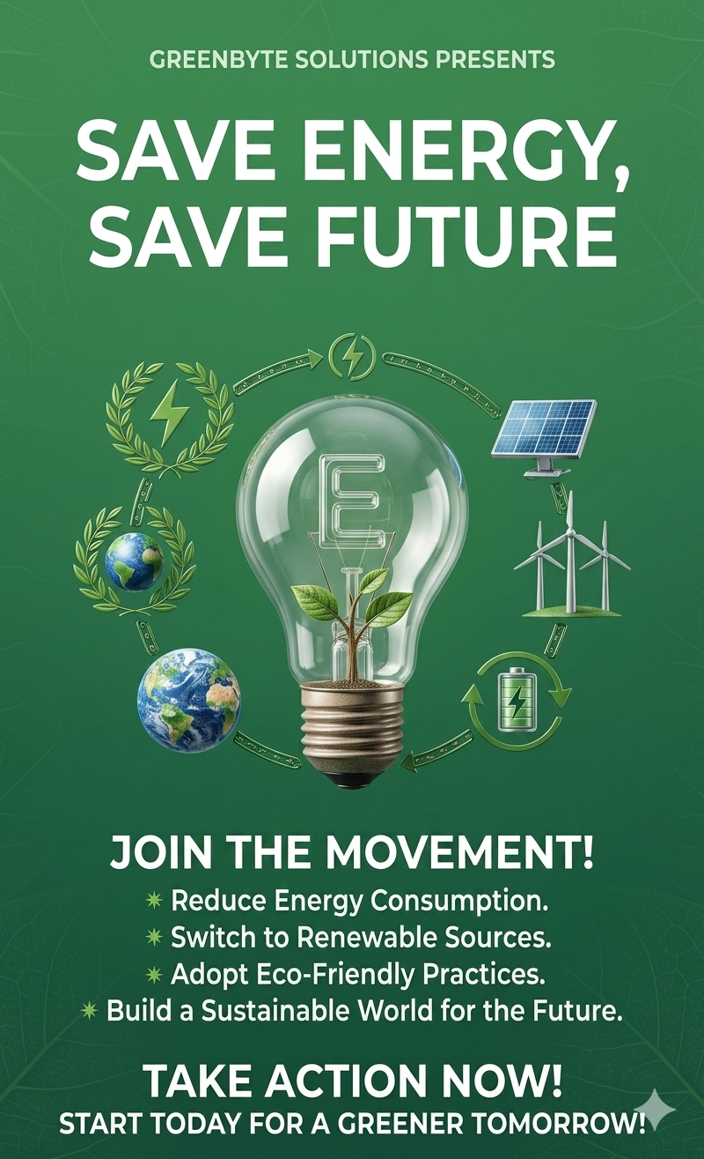
I make this poster by using canva’s tool, green background and used clear and readable fonts for title and body, in the main part of the poster I used an image of energy consumption reduction.
Theme & Color: I chose a Green/Eco-friendly theme using different shades of green to represent nature and sustainability.
Typography: I used bold, clean fonts for the title "Save Energy, Save Future" to make the message clear and easy to read.
Central Visual: I placed a minimalist light bulb icon with a leaf/tree inside it to symbolize "Clean Energy."
Icons: I added simple symbols like solar panels, wind turbines, and recycling signs to represent environmental awareness.
Layout: I kept the design centered and balanced, with plenty of "white space" so it doesn't look cluttered.
Call to Action: I included a bulleted list at the bottom to tell people exactly how they can help.

